**East West University**

**LAB REPORT**

|  |  |
| --- | --- |
| **Course Code and Name:**  CSE 209 ; ELECTRICAL CIRCUIT | |
| **Experiment no: 07**  **Group no: Individual** | |
| **Experiment name:**  DC Circuit Analysis in PSpice using Source and Resistance Sweep | |
| **Name of student & Id:** | |
| B M Sharhia Alam | **ID:** 2021-3-60-016 |
| **Course Instructor information:**  M Saddam Hossain Khan(SHK)  Senior Lecturer  Department of Computer Science and Engineering  East West University | |
| **Date of Report Submitted:**  26 December ,2022 | |

**OBJECTIVE:**

1. To analyze DC circuit in PSpice by sweeping source and resistance.

2. To verify maximum power transfer theorem.

**INTRODUCTION:**

In PSpice, DC analysis may be performed by varying the value of a DC voltage source or by varying a resistance. The results of such sweeps may be graphically viewed using the Probe tool of PSpice.

**THEORY AND EXPERIMENTAL METHODS:**

**METHODS:**

The open circuit voltage between the terminals and Rth is the ratio of the open circuit voltage to the short circuit current through the terminals.

**CIRCUIT DIAGRAM:**



**Figure 1: Example circuit.**

**Step: 1**



**Step: 2**



**Step: 3**

Eth = Voc = 5V

Rth = Voc /Isc = 5/400 =0.0125k =12.5Ω

RL = Rth =12.5Ω

**Step: 4**



**To determine V(1), V(2) and I(R3):**

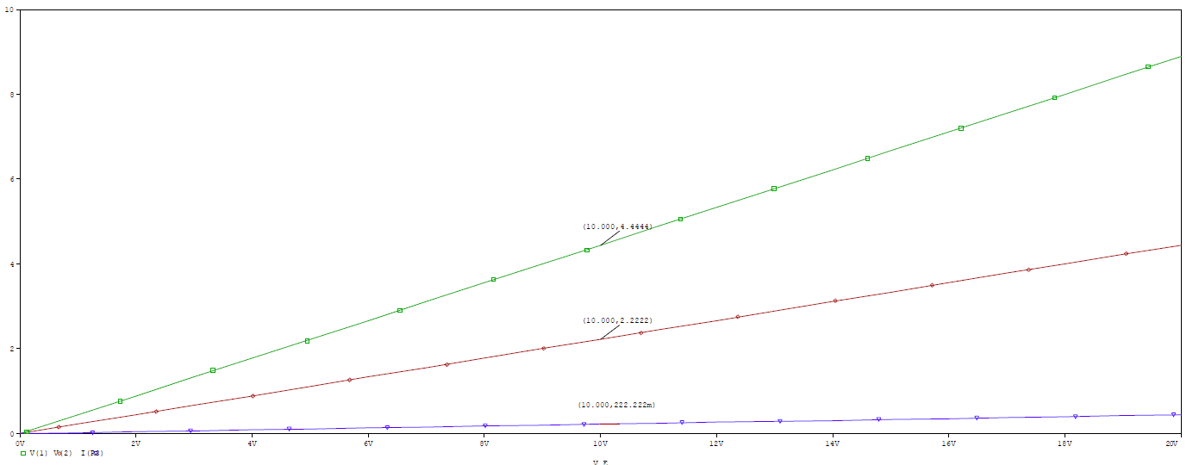

V(1) = 4.444V, V(2) = 2.222V and I(R3) = 222.22mA

**Step 5:**



**Step 5(d): To determine V(1), V(2) and I(R3) for R = 10 ohm:**

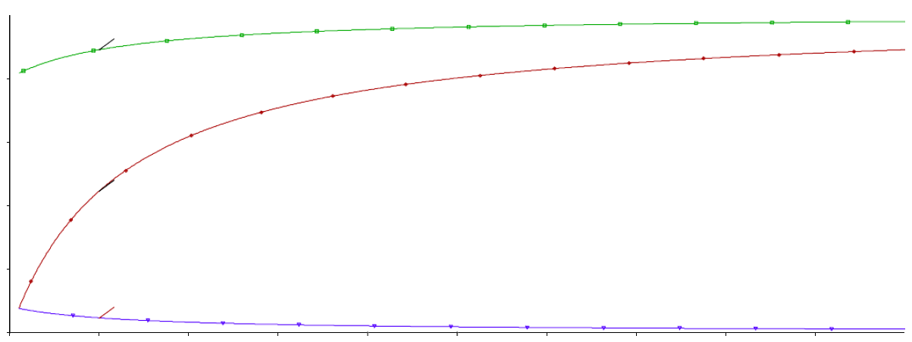

V(1) = 4.444V, V(2) = 2.222V and I(R3) = 222.22mA

**Step 5(e):** Graph to determine the maximum value of the load power and the value of RL= 12.5 Maximum value of the load power, PLmax=5W

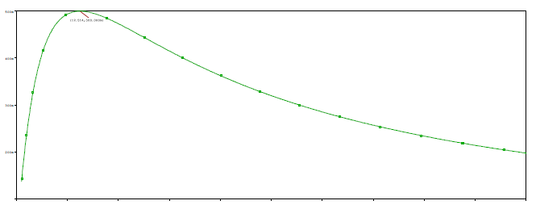

**Post-Lab Report Answers:**

**Answers to the questions no: 01**

Comparing the values of V(1), V(2) and I(R3) obtained in steps 4 and 5(d):

|  |  |  |
| --- | --- | --- |
|  | Step-4 | Step-5(d) |
| V(1) | 4.444V | 4.444V |
| V(2) | 2.222V | 2.222V |
| I(R3) | 222.22mA | 222.22mA |

So, here is no difference between the step 4 and step 5(d) values.

**Answers to the questions no: 02**

From step 2,

Load resistance = 12.5

From step 5(e),

Load resistance = 12.5

Comparing the load resistance for maximum power transfer obtained in steps 2 and 5(e):

Step2:

Load resistance = 12.5

Step 5(e):

Load resistance = 12.5

So, here is no differences between the step 2 and step 5(e) value.

**Answers to the questions no: 03**

**Theoretical solution:**



Kcl at node 1,

⇒V1=4.44V

Now,

I(R3) = V1/20 =4.44/20=0.22A

So, V2=RL×I(R3)= 10×0.22=2222V

**PSpice Simulation:**



I(R3) = 222.22mA V(1) = 4.444V V(2) = 2.222V and Comparing the theoretical and PSpice solution:

**PSpice solutions:**

V(1) = 4.444V, V(2) = 2.222V and I(R3) = 222.22mA

**Theoretical solutions:**

V(1) = 4.444V, V(2) = 2.222V and I(R3) = 222.22mA

So, here is no differences between the theoretical solutions and PSpice solutions.

**Result & Discussion:**

**PSpice data:**

Measured values are = 12.5Ω, V(1) = 4.444V, V(2) = 2.222V and I(R3) = 222.22mA

There are some a little differences between the theoretical values and the experimental measured values. Pre-Lab data and experimental data are also almost same. From this experiment, we slightly broaden our knowledge we gained from the previous experiment. By doing this experiment we have been able to simulate our circuits via PSpice and test the results. After doing this experiment we gain knowledge about maximum power transfer theorem.

**Theoretical data:**

Theoretically calculated values = 12.5Ω, V(1) = 4.444V, ( ) =2.222V and I(R3) = 222.22mA

**Conclusion:**

While doing the experiments, the readings were taken very carefully. Though there is no slightly difference between calculated value and PSpice value, at the end of the experiment we finally gained practical knowledge about Superposition theorem.

**Pre lab:**

